Use Case Specification

DMT/RM01/TMP

|  |  |
| --- | --- |
| Project Code | Leave Applicationl_001 |
| Project Name | Leave Application |

|  |  |  |
| --- | --- | --- |
| Prepared/Modified by | Role | Date of Preparation |
| Mallishwari | Test Engineer | 19/04/2018 |
| Reviewed by | Role | Date of Review |
|  | SME |  |
| Approved by | Role | Date of Approval |
|  | Test Manager |  |
| Circulation List |  | Version Number of the template: |
| Version Number | 1 |  |

<<Customer>> REVIEW HISTORY

<<Customer comments on the Use case along with the signed off is tracked here>>

|  |  |  |  |  |  |  |
| --- | --- | --- | --- | --- | --- | --- |
| Version | <<Version number>> |  |  |  |  |  |
| Date | <<Date of Review>> |  |  |  |  |  |
| Reviewed by | << Reviewer Name>> |  |  |  |  |  |
| Reviewed UI Specification doc | << Whether UI Specification doc is reviewed >> |  |  |  |  |  |
| All Open Queries/issues closed | << Whether all the open queries and issues resolved>> |  |  |  |  |  |
| Agreement on Assumptions | <<Whether all the assumptions have been agreed upon by the customer>> |  |  |  |  |  |
| Sign Off | <<Signature>> |  |  |  |  |  |

Disclaimer:

The scope of the project ‘<<Project Name>>’ is restricted to the contents of this signed off use case.

TABLE OF CONTENTS

1.Use Case Name: <<Leave Application>> 4

2.Actor(s) 4

3.Preconditions 4

4.Flow of Events 4

4.1 Basic Flow 4

4.2 Alternative Flows 5

4.2.1 Alternate Flow 1 5

4.2.1 Alternate Flow 2 5

4.3 Exception Flows 6

4.3.1 Exception Flow 1 6

4.3.2 Exception Flow 2 6

4.3.3 Exception Flow 3 6

4.3.4 Exception Flow 4  7

4.3.5 Exception Flow 5  7

5.Post Conditions  8

6.Special Requirements  8

7.Business Rules  9

8.Diagrams  10

Use Case Diagram  10

9.Scenarios 11

Success Scenarios 11

Failure Scenarios 11

10.Issues 11

11.Assumptions 11

REVISION HISTORY OF THE WORK PRODUCT………………… 11

Use Case Name: online banking system

Use Case ID: LeaveApplication1.0

**Brief Description**: This usecase describes the process of applying leave in an organization.

Actor(s)

1.Employee

2.System

Preconditions.

1 User is employee of company and having access to Intranet

2.User has leave balance for applying a leave

Flow of Events

4.1 Basic Flow

**Name:** Successful Leave Application

1. Employee will access Intranet

2. Employee clicks on Employee Corner

3. Employee clicks on Attendance System

4. Employee selects Leave Application

5. Leave application form will be displayed.

6. Employee enters invalid Username

7. Employee enters valid Password

8. Employee clicks on the ok button

9. The system validates Username & Password

10. The system displays an error message “Invalid username”.

Alternative Flows

Alternate Flow 1: Successful Leave Application

1. Employee will access Intranet

2. Employee clicks on Employee Corner

3. Employee clicks on Attendance System

4. Employee selects Leave Application

5. Leave application form will be displayed.

6. Employee enters invalid Username

7. Employee enters valid Password

8. Employee clicks on the ok button

9. The system validates Username & Password

10. The system displays an error message “Invalid username”.

11.The employee enters correct username and password

12.The system navigates Employee Home Page

13.Employee clicks on “Leave Request” link from the homepage

15.Employee fills all valid details in the form and submits the form.

Alternate Flow 2: Successful Leave Application

1. Employee will access Intranet

2. Employee clicks on Employee Corner

3. Employee clicks on Attendance System

4. Employee selects Leave Application

5. Leave application form will be displayed.

6. Employee enters valid Username

7. Employee enters invalid Password

8. Employee clicks on the ok button

9. The system validates Username & Password

10. The system displays an error message “Invalid username”.

11.The employee enters correct username and password

12.The system navigates Employee Home Page

13.Employee clicks on “Leave Request” link from the homepage

15.Employee fills all valid details in the form and submits the form.

Exception Flow 1: unsuccessful Leave Application due to more no of login attempts

. 1 . Employee will access Intranet

2 . Employee clicks on Employee Corner

3 . Employee clicks on Attendance System

4. Employee selects Leave Application

5. Leave application form will be displayed.

6 . Employee enters valid Username

. 7. Employee enters invalid Password

8. Employee clicks on the ok button

9. The system validates Username & Password

10. The system displays an error message “Invalid username”.

11. The system validation fails due to more no of lolgin attempts.

12 .The system suspends the Employee account

13.The system informs the Employee that his/her account has been suspended

Exception Flow 2 :unsuccessful Leave Application due to Required fields are not filled

1. Employee will access Intranet

2. Employee clicks on Employee Corner

3. Employee clicks on Attendance System

4. Employee selects Leave Application

5. Leave application form will be displayed.

6. Employee enters valid Username

7. Employee enters invalid Password

8. Employee clicks on the ok button

9. The system validates Username & Password

10.The system navigates Employee Home Page

11.Employee clicks on “Leave Request” link from the homepage

12**.**The employee does not enter the values in required field

13.The system displays an error message as “Fill all the required fields.”

Exception Flow 3: Web Server Down

1. Employee will access Intranet

1 2. Employee clicks on Employee Corner

3. Employee clicks on Attendance System

4. Employee selects Leave Application

5. Leave application form will be displayed.

6. Employee enters valid Username

7. Employee enters invalid Password

8. Employee clicks on the ok button

9. The system validates Username & Password

10. The system displays an error message regarding web server unavailability problem

Exception Flow 4: Database Connectivity Error

1. Employee will access Intranet

2. Employee clicks on Employee Corner

3. Employee clicks on Attendance System

4. Employee selects Leave Application

5. Leave application form will be displayed.

6. Employee enters valid Username

7. Employee enters invalid Password

8. Employee clicks on the ok button

9. The system validates Username & Password

10.The system displays an error message regarding database connectivity problem.

Exception Flow 5: Network Connectivity Error

1. Employee will access Intranet

2. Employee clicks on Employee Corner

3. Employee clicks on Attendance System

4. Employee selects Leave Application

5. Leave application form will be displayed.

6. Employee enters valid Username

7. Employee enters invalid Password

8. Employee clicks on the ok button

9. The system validates Username & Password

10.The system displays an error message regarding network connectivity problem.

Post Conditions

| Flow Name | Post Condition |
| --- | --- |
| Successful Employee login to the website | Employee will be logged in to website and Home Page should get displayed |
| Employee clicks on the Leave Request Link | Employee will be redirected to Apply for Leave form and the form should be displayed |
| Exceeded Login Attempts | The system should suspend the Employee account and should inform the Employee that his/her account has been suspended |
| Web Server Down | The system should display an error message to the user regarding web server unavailability problem |
| Database Connectivity Error | The system should display an error message to the user regarding the database connectivity problem |
| Network Connectivity Error | The system should display an error message to the user regarding the network connectivity problem |

Special Requirements

Performance

The click on ‘Leave Request’shall display the Apply for Leave form within 15 seconds.

Availability

Application is up and running 24*7.

Business Rules

| Business Rule Name | Business Rule Description | System action (if BR fails) |
| --- | --- | --- |
| BR01 | Employee must be valid | Employee is prompted to re-enter the login credentials |
| BR02 | Start date should be current date or future date | Displayes error message “Start date cannot be in the past” |
| BR03 | End date should be current date or future date. | Displayes error message “End date cannot be in the past” |
| BR04 | All fields to be filled | Displayes error message “No fields should be empty” |
| BR05 | No exceeded login attempts | Displayes error message “Account has been suspended” |

Diagrams

Use Case Diagram

For Successful unscheduled cab request

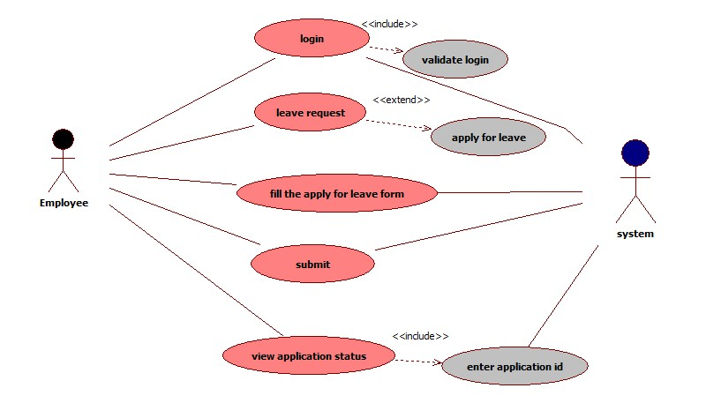







Scenarios

Success Scenarios

* Successful submission for Leave

Failure Scenarios

1. Exceeded Login Attempts
2. Web Server Down
3. Database Connectivity Error
4. Network Connectivity Error
5. Required fields not filled

Issues

1. What is to be done if web server is down?

2. What is to be done if there is data connectivity error?

Assumptions

1.The Employee should be authenticate

2. Employee should know the valid URL of website

REVISION HISTORY OF THE WORK PRODUCT

<to be maintained by projects>

|  |  |  |  |  |  |
| --- | --- | --- | --- | --- | --- |
| # | Date | Version # | Section Changed | Details of changes made | Approved By |
| 1 |  |  |  |  |  |
| 2 |  |  |  |  |  |